Shabbos Stories for
Parshas devorim 5781
Volume 13, Issue 47 8 Menachem Av/July 17, 2021
Printed L’illuy nishmas Nechama bas R’ Noach, a”h

For a free subscription, please forward your request to keren18@juno.com
Past stories can be found on the website ShabbosStories.com

Charlie’s Hot Dog Challenge
By Rabbi David Ashear
We’re always Hashem’s children, and He loves when we come closer to Him. If someone ever feels that Hashem is pushing him away, it’s only because he’s not understanding Hashem properly.
Rabbi Yechiel Spero told a story about a man named Charlie from Chicago. He had been attending classes at the Migdal Torah institution which was created to help bring back ba’aleh teshuva. Charlie seemed interested in Judaism but was never able to take any steps towards mitzvah observance.
One day, the Rosh Yeshiva Rabbi Avraham Alter approached Charlie and spoke to him about making some sort of commitment to becoming more observant. Charlie told the Rabbi, “You’re right, it’s time. I want to accept upon myself to start keeping kosher.”
But he added, “I’m going to start tomorrow.” There was a certain kind of hot dog that Charlie was infatuated with. He wanted to go one last time before he would give it up for good. So Charlie went to his favorite eatery and ordered his final unkosher hot dog with all its trimmings. As he was about to take the first bite, a fellow in a business suit sat down across from him.
They began to chat and when Charlie realized this man wasn’t leaving any time soon, he began to eat and enjoy the last bites of this forbidden food. Suddenly, the man who introduced himself as Larry asked him, “Do you like that hot dog?” Charlie replied, “I don’t just like it, I love it. But this is going to be the last one I’ll ever have.”
The man looked intrigued, “Really? Why?”
Charlie didn’t feel comfortable talking to him about his acceptance of eating kosher, so he just told him, “It’s too expensive.”
Larry replied, “I don’t want to see you give up on eating here because of money. I’m actually the owner of this restaurant, and I’m going to help you.” With that, he pulled out a card from his pocket which read, “This card entitles you to a lifetime supply of hot dogs.”
Charlie was confused. He ran back to his Rabbi and said, “I don’t understand. I tell Hashem I’m ready to keep kosher, and He gives me a lifetime supply of my favorite non-kosher food? It seems like He doesn’t want me taking this step. He doesn’t want my avodah.”

Rabbi Avraham Alter

Rabbi Alter told him, “My dear student, you’re getting it all wrong. You thought you were only on the level of giving up your favorite food that you still had to pay for. Hashem knows you’re at a point where you can give it up even if you would get it for free for the rest of your life. This will make your commitment so much better and worth so much more. I want you to place this certificate in a frame and display it prominently so you could look at it and remind yourself of how much Hashem believes in you.”
Charlie kept that commitment and, in time, it led to another commitment and another commitment and today he is fully observant and still has that certificate hanging on his wall. Hashem never pushes anyone away. He’ll only give us opportunities to come even closer to Him. We should always feel loved and welcome to perform all of the mitzvot.

Reprinted from the Parshat Shelach 5781 edition of iTorah.com
A Peculiar Blessing

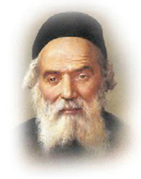

The Hafess Hayim called his wagon driver into his study. “I understand that you are traveling to Salant. Please speak to R’ Yosef Zundel,” the Hafess Hayim requested. “Ask him for a blessing on my behalf.” R’ Yosef Zundel was famous throughout Lithuania for his vast Torah knowledge and piety. His blessings were valued and treasured by some of the greatest names in the Torah world.
The wagon driver duly went to R’ Yosef Zundel’s home and asked, in the name of the Hafess Hayim, for a blessing. R’ Yosef Zundel thought for a moment, then replied, “May it be Hashem’s Will that you walk barefoot and bear stones!”
The wagon driver was shocked. This was the prized blessing that the Hafess Hayim had wanted? R’ Yosef Zundel’s words seemed so strange, so utterly bizarre, that the man thought it would be wiser not to mention them to the Hafess Hayim at all. He returned to Radin and went about his business, avoiding the Hafess Hayim entirely.
A day later, he received a summons from the Hafess Hayim. “I see you have returned from Salant,” the Hafess Hayim said. “Why haven’t you brought me an answer from R’ Yosef Zundel?”
“Rebbe,” the wagon driver stammered, “I went to R’ Yosef Zundel, but he - he didn’t make sense! I couldn’t pass on a blessing like that!”
“Why not let me judge for myself?” the Hafess Hayim gently suggested.
The wagon driver, embarrassed to repeat R’ Yosef Zundel’s peculiar blessing, muttered, “He said that Hashem should bless you to walk barefoot, and to bear stones.”
The Hafess Hayim smiled. “Ah, what a blessing!” he sighed. “May it come true very soon…And it would be enough to walk barefoot, without bearing stones as well!”
His family asked, “How could this be a good blessing? What does it mean?”
“Why, it’s simple,” the Hafess Hayim explained. “As you know, I am a Kohen. R’ Yosef Zundel blessed me that I should soon merit to serve Hashem in the Bet Hamikdash, where the Kohanim walked barefoot as they performed their duties. He also blessed me that I should merit to serve as Kohen Gadol, and bear the twelve stones of the hoshen; but as for me, I would be content to be ‘merely’ a Kohen, and serve Hashem in His Holy Temple - may it be rebuilt speedily, in our days!” (Taryag Tales)

Reprinted from the Parshat Korach 5781 email of Rabbi David Bibi’s Shabbat Shalom from Cyberspace.

An Unexpected Shiva Call

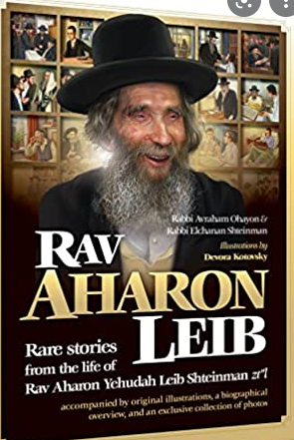

A fellow paying a shiva call in Yerushalayim seemed confused when he didn’t recognize the mourners. It turned out that he was in the wrong house, as the family of the same name he intended to visit lived a few streets away. However, being that he was there, he sat down to be menachem aveil.
The visitor was a Gabbai of R’ Aharon Leib Shteinman z”l, and as it turned out, the husband of the nifteres had been a student of R’ Aharon Leib fifty years before. They traded stories and recollections of R’ Aharon Leib, and then the Gabbai left and went to the other shiva house.
Upon his return to Bnei Brak, he mentioned this occurrence to R’ Aharon Leib. Though he didn’t remember this talmid, he told the gabbai to take him to Yerushalayim, where he sat with the man for 25 minutes before returning home. At nearly 100 years old and with a very busy schedule, R’ Aharon Leib’s trips to Yerushalayim were always planned in advance, but when he heard a Talmid had lost his wife, there was nothing to discuss. He had to go to comfort him.

Reprinted from the Parshas Korach 5781 email of Jonathan Gerwitz’ Migdal Ohr.

The True Foundation of
The Ponevizher Yeshiva
By Rabbi Joey Haber

A beautiful example of this kind of faith is a story told of the Ponevizher Rav, Rav Kahaneman, who built the Ponevizh Yeshiva in Bnei-Brak. On the day the foundations of the yeshiva were laid, Rav Kahaneman sat on the stone and cried for a long while.
The next day, he explained to his students why he cried. “I cried,” he said, “because the foundation of this building was laid not yesterday, but 57 years ago.” He told that 57 years earlier, he was a young boy living with two older brothers in Russia, in a state of utter destitution. Once, on a snowy, bitterly cold winter day, the family had only one jacket and one set of boots for everyone.
The mother turned to the boys and asked which of them wanted to go to yeshiva the following day. Because of the weather, and because there was only a single coat and pair of boots, only one would be able to get to yeshiva the next day. All three said they wanted to go. The next morning, the mother took each child to yeshiva, one by one, wearing the boots and carrying the boy on her back with the jacket covering both of them.
Rav Kahaneman recalled hearing his mother sing as she carried him and trudged through the snow about how fortunate she was, how fortunate the family was, that they had three boys learning Torah.
“At that moment,” Rav Kahaneman said, “I said to myself that I needed to build a yeshiva on her sacrifice. As I stood on that stone, I remembered my mother’s sacrifice.”
Let us imagine for a moment that none of this happened, that the Kahaneman family lived comfortably in Russia, and had boots and jackets for everyone, so that the mother that morning would have just bid her children farewell as they left to yeshiva, like all parents do.
This young impressionable boy would never have learned this priceless life lesson. Who knows if he would have grown to build a Torah empire if he had not had this remarkable educational experience? Hashem gave the Kahaneman family exactly what they needed to ensure that the Ponevezh Yeshiva would be built 57 years later.

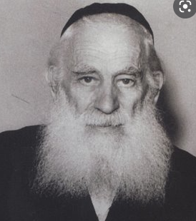
Rabbi Joseph Shlomo Kahaneman, zt”l (1888-1969)

And this is true of our lives, as well. Hashem always gives us what we need to do what we are supposed to do. We should rejoice over everything we have, without every worrying about what we don’t have. If we live this way, then we will live with genuine joy and contentment, each and every day, and will never feel the desire to exchange our life for anyone else’s.

Reprinted from the Parshat Shelach 5781 edition of iTorah.com

The Reward for Answering Trivial Kashrut Questions
By Rabbi Yosef Farhi

My mother, may she merit all the blessings of the Torah, told me last Shabbat the following story. For those who don’t know, my mother, answers all the Kashrut questions regarding the different products, for the JSOR, the Kashrut of Deal, where my father is the Supervising Rabbi and coordinator.
One of the most amazing things about the Syrian community is that there are women who, according to the way they dress, you would never think they would be so particular when it comes to Kashrut. My mother who answers the questions of the three WhatsApp chats, of 1000 people each, said that there was one such particular woman who would bombard my mother with questions, of even things like the kashrut of soap. My mother always answered her questions with due diligence, no matter how trivial they seemed to be.
One time, this woman Whatsapped my mother. “Mrs. Farhi, I ask you the smallest questions and you always are so kind to take the time to answer me. Mrs. Farhi, I am presently in the hospital, and I am on the bed waiting for the doctor to come in and do an abortion. The doctor said the baby will not be a healthy one, and it will be a big deal to me and my family to have such a baby. I just had this thought that if I ask you every small question, I should ask your advice regarding this question, as well.”
My mother responded that she does not have the authority to answer such questions, but to wait, as she will immediately take the details of the doctor’s opinion, and my father will bring it to the authority who is able to answer such questions, R’ Moshe Feinstein’s closest, right-hand man. The woman waited for the response. The Rabbi said that she cannot go through with the abortion!
This woman got off the bed and started preparing to leave. The doctor came into the room and asked her where she was going. She said, “My Rabbi said I cannot make an abortion, so I do what my Rabbi tells me.”
The doctor gave her this confused, and then angry, look. “Ask your Rabbi, if he is willing to be the one to bring up this child!”
The woman, calmly, turned toward to the door, confidently saying, “I trust my Rabbis. I only put in my body what they tell me to. And, I will not take out of my body what they tell me not to.”
It turned out that the baby girl needed just minor surgery, and was totally fine! My parents help people they never saw, including this woman, just because they are Jews! Ten years later, when my parents were in the airport before a flight, they noticed a mother and a 10-year-old girl, pointing at them.
My parents asked if everything was okay. Do we know you from somewhere, or do you know us? The mother explained with a tear in her eyes, “Yes, this daughter is the girl that I almost killed. But because of my trivial Kashrut questions, you saved this daughter. Thank you!”

Reprinted from the Parshat Korach 5781 email of Rabbi David Bibi’s Shabbat Shalom from Cyberspace.

An Unusual Bikur
Cholim Visit

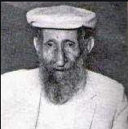

Horav Chaim Toito, Shlita, relates a story from which he gleans a deeper understanding of the relationship of pekidah (yipakeid u’fekudas) with visiting the ill. Chacham Sulamon Mutzafi, zl, was one of the premier kabbalists in Yerushalayim during the early twentieth century.
For the duration of an entire year, he would visit one of Yerushalayim’s distinguished rabbanim who had become seriously ill and was confined to bed. Every Friday night, following davening, he would stop by the Rav’s house to spend an hour discussing issues confronting the Jewish community and asking the Rav for his sage advice.
All this was carried out prior to Rav Sulamon’s going home. Considering the extra time it took to walk to the Rav’s house and the duration of the time spent there, the Sulamon family (and his students) waited an hour and a half longer than other families. No one complained, but the students (who always valued the opportunity for learning) wanted to know why he spent so much time visiting the Rav.
The Chacham explained, “The Rav whom I visit every Friday night is a great scholar, who would ordinarily leave the shul on Friday night accompanied by a throng of followers, all thirsting for knowledge, who peppered him with questions on halachah, or to glean his sage advice.
“Now that he is ill and bedridden, in addition to the pain generated by his illness, he is also dispirited over being alone. Therefore, even though subjecting them to wait for me places a burden on my family, I am during this hour performing the mitzvah of bikur cholim, visiting the sick, in accordance with halachah.”
This vignette underscores the meaning of visiting the sick. It is not about walking in, greeting, talking a few moments and leaving. The mitzvah of bikur cholim is about filling the bedridden person’s needs. We must ask ourselves: “What is he/she missing most? What does he/she need?” Visiting the ill should not be about assuaging the visitor’s guilt feelings, but about filling the void in the life of the choleh.

Reprint of Rabbi A.L. Sheinbaum’s Parshas Korach 5781 email of the Peninim on the Torah.

Rav Aryeh Levin’s Newly Discovered “Relative”

Horav Aryeh Levin, zl, reverently known as the Tzaddik of Yerushalayim, devoted his life to the pursuit of all things chesed – especially in the areas from which others shied away. In prisons, leper colonies, mental health wards, he focused on the forgotten and ignored. He sought to fill the void that most of these lonely people needed most: friendship.
They knew that in him they had someone who truly cared. For example: (this could go on for many pages, but I have only selected one instance): Rav Aryeh would visit the mental wards where individuals who had suffered serious emotional challenges were treated until they were able to return to society. (These were the lucky ones who knew they had a problem and were willing to do something about it.)
One day, he saw a poor soul who was covered with black and blue welts and bruises. Needless to say, Rav Aryeh became interested in this man’s welfare. He asked what had happened to him.

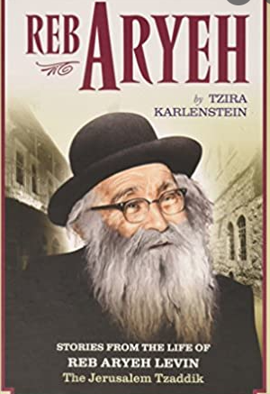

The other patients explained, “We are all ill, strung out beyond our emotions’ ability to cope. We are here for treatment. There are difficult moments when we lose it and become wild. The orderlies must restrain us forcibly, and, at times, it gets out of hand. They even have to subject us to corporal beatings in order to control us. We all have family and relatives with whom the orderlies do not want to hassle.
Therefore, the beatings are not injurious. That man, however, has no family. So the orderlies expend all their frustration on him. Whenever they have a difficult day, they release their frustrations on him.”
When Rav Aryeh heard this, he walked over to the orderlies and informed them that the man/patient was his relative. He would check on him and see to his continued welfare. From then on, he visited the man every Rosh Chodesh and always brought along a little gift. He realized what the man had been lacking: a relative. Rav Aryeh filled the void and became his relative.

Reprint of Rabbi A.L. Sheinbaum’s Parshas Korach 5781 email of the Peninim on the Torah.

A 20-Year Delay in a Heavenly Decree

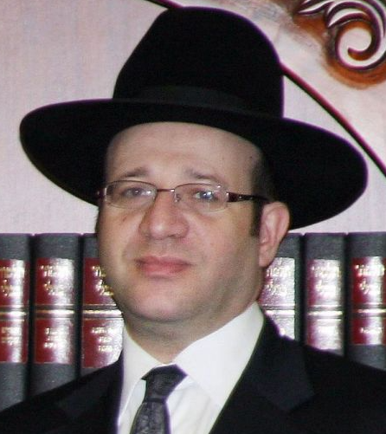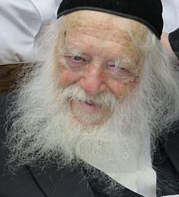
Rav Ben-Tzion Dunner Rabbi Chaim Kanievsky

REBBETZIN KANIEVSKY TOLD the following story to Rav Yitzchok Zilberstein. A few weeks after the tragic petirah of the great baal tzedoka (philanthropist) Rav Ben-Tzion Dunner, tz”l, a group of people came to visit Rav Chaim Kanievsky, shlita
When they were there they mentioned some great attributes about Rav BenTzion and how sad and terrible the loss was. Rav Chaim then turned to the people who were standing there and said to them, "Do you think that this gezirah (heavenly decree) was just decided now? Not at all! In fact, this gezira was already made 20 years ago, and his years on this world were already finished. However, because of the unbelievable generosity, chessed and charity that he performed they pushed off his severe decree in shomaym (heaven) that he should live another 20 years!"
The people who heard this coming from the mouth of Rav Chaim א''שליט immediately thereafter went and phoned the family of Rav Dunner living in London, since such words could perhaps give a nechama (consolation) to the family.
And what was the Almana's response when they told her what Rav Chaim said? "Yes" she replied. "I know exactly which incident Rav Chaim was referring to. Exactly 20 years ago from when he was niftar (passed away), he was in a terrible car accident and he came out unscratched only by way of an open miracle. In fact, the people who witnessed the scene said testimony that bederech hateiva (according to normal nature of life) no human being could have made it out of such an accident alive."

Reprinted from Parshas Korach 5781 email of Eitz HaChayim.

The Sholosh Seudos Vort
Of the Chofetz Chaim

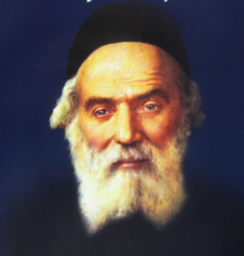

Rav Dovid Hoffman relates that when the Bolsheviks seized power in Russia in 1917, the upheaval forced many people to relocate. The saintly Chofetz Chaim, Rav Yisroel Meir HaKohen Kagan, zt”l, who had left Radin temporarily during World War I, was forced to settle in the small city of Snovsk.
There is always a shortage of food during a war, and by the Russian Revolution, the situation was worse than during other wars, because a decree was issued that anyone who possessed food was required to hand it over to an official appointed for this purpose. That official would then distribute food rations to each family, at his discretion.
Because of this arrangement, there were many families who did not have enough to eat. The Chofetz Chaim resolved to collect whatever extra food families might have and divide these scraps among the poorest families. When the war finally ended in 1921, the Chofetz Chaim announced that he was returning to Radin.

The Last Shabbos in Town
On the Shabbos before he left, the Chofetz Chaim invited the congregation to his house for Sholosh Seudos. On the way to the Chofetz Chaim’s home, they came across the officer who was in charge of the city. He was a cruel man. His parents were Jewish but were not at all religious, and their son had continued along the same path.
At one point, he had joined the revolution against the Czar, and had been exiled to Siberia. When the Bolsheviks took over, they freed him and appointed him as the officer in charge of this city. He disliked all religious Jews, except for the Chofetz Chaim, whom he had deep respect for.
The Chofetz Chaim said to him, “Could you come to my house for Shalosh Seudos, the third meal?”
The officer answered him mockingly, “I have already eaten the ‘third meal’. I have eaten much more than three meals!”
The Chofetz Chaim persisted and finally the officer reluctantly agreed. At the end of the meal, the Chofetz Chaim said to the officer, “I want to ask you for a favor, but first, I must tell you a Vort.”
“A ‘Vort’?” laughed the officer. “Why do I need to hear a ‘Vort’? Surely I will not understand it!”

The Tree in the Center of the Garden
The Chofetz Chaim replied, “Even a child could understand what I am going to tell you. The Torah says in Parashas Bereishis that Hashem made every tree, with the Tree of Life in the middle of the garden, and the Tree of Knowledge of Good and Evil. Rashi explains that the Tree of Life was exactly in the center of the garden. Why was this? It is because the Tree of Life is the focus of life. This refers to eternal life, the life of the World to Come. Hashem wants every Jew to receive his portion in the World to Come.
“A person can achieve this through Davening, through learning Torah, or through giving Tzedakah. Perhaps a person will claim that Mitzvos are too far from him, and they are not within his reach. Therefore, Hashem put the tree exactly in the center of the garden, to show us that it does not matter where one is standing. A person can approach the tree from any direction, and have the opportunity to earn S’char in Olam Haba.
“Upon you,” continued the Chofetz Chaim to the Bolshevik official, “the Ribono Shel Olam also has mercy. Who knows? Perhaps you were put into power for the sole purpose of fulfilling the request which I am about to make of you.”
The Chofetz Chaim sighed, “During the war, I went around and collected food for the poor families of this city. Now I am going back to my own town. I am giving you a list of these poor people, and I want you to accept upon yourself to provide them with food, just as I did. You cannot say that you are unable to do so, because you are in charge and everyone here has to listen to you. Do this, and I assure you that you will reach some level in Olam Haba.”
This officer had a heart of stone, but words which come from the heart can enter any heart, and the words that came from the Chofetz Chaim’s heart, penetrated the officer’s heart. He said to the Chofetz Chaim, “Give me the list, Rabbi, and I will do it.” And amazingly, he did!

Reprinted from the Parshas Korach 5781 email of Rabbi Yehuda Winzelberg’s Torah U’Tefilah.

The Broken Oath

Tosafos in Taanis (8a) tells a story about a girl who was walking home one day and fell into a pit. A young man who happened to pass by promised to rescue her, on the condition that she would marry him at a later time that he would decide. The girl had no choice and gave her consent. They both took an oath, making the pit and a passing weasel their witnesses.
With the passing of time, the girl was willing to keep her promise, but the young man chose to marry someone else. Two sons were born to him from this marriage, but unfortunately, both met a tragic end. One son was killed by a weasel, and the second son fell into a pit and died from his injury.
His poor wife, beside herself with grief, asked him how such a thing could have happened. She wanted him to think if there was anything in his past that could have led to the bizarre misfortune that had befallen them. Finally, he recalled the commitment he had made to the young woman he had rescued from the pit. Both of them, because of their loss, recognized the dire consequences of a broken promise, agreed to divorce to allow the husband to keep the promise he had broken. Shlomo Ha’melech said in Koheles (5:4), “It is better that you not vow at all, than if you make a vow and not fulfill it.” A vow is a most serious undertaking!

Reprinted from the Parshas Korach 5781 email of Rabbi Yehuda Winzelberg’s Torah U’Tefilah.

